25.21. Help menu

Help > About mSupply
Choosing this item displays information about your mSupply installation.
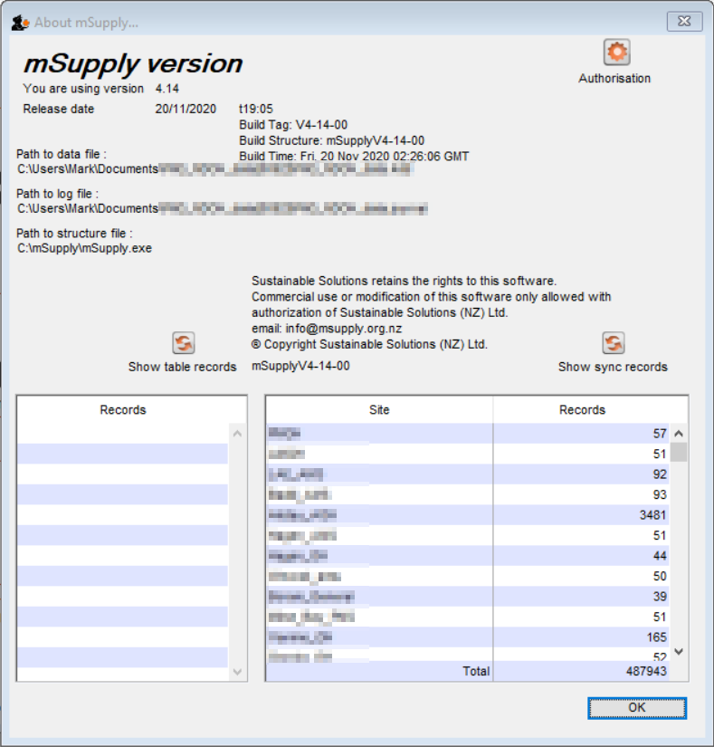

Authorisation
The Authorisation button is provided largely for our support team to assist with resolving any issues. You can safely ignore it.

Show table records
Clicking this button will result in a list of the number of records in each of the data 'tables' in your mSupply system. This is only generally of technical interest. You can safely ignore it.
On a large mSupply system, it can take some time to generate this list.

Show sync records
Clicking this button will result in a list of the number of outstanding 'sync-out' records, broken down by sync site. These are records of data that have been queued up for the site, but have not yet been sent for any number of reasons (no internet connection, site device is powered down, site credentials are not correct, etc.). This list is not dynamic, in that you will not see the numbers count down as the records are synced out. The numbers are generated each time the button is clicked, and remain static.
The existence of a significant number of sync out records indicates that the site has not synced with the central server for some time. If the site has been in normal operation during this time, then there will also likely be a significant number of records waiting to be synced back from the site. In these cases, once a sync connection is reestablished, it could take hours for all the sync records to be transferred.

Updating mSupply
For single user versions of mSupply, you can see if you have the latest version by choosing Special > Check for updates
Choosing this item from the Special menu will connect to the mSupply web site and compare your current mSupply version with the version you are now using.
If an update is available, you will be shown a window where you can click to download the latest version.
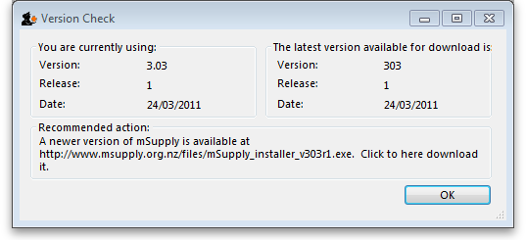

Previous: 25.20. Server troubleshooting | | Next: 25.22. Field descriptions

